# 

# Program 01

A Prime-Adam integer is a positive integer (without leading zeros) which is a prime as well as an Adam number.

Prime number: A number which has only two factors, i.e. 1 and the number itself. Example: 2, 3, 5, 7 ... etc.

Adam number: The square of a number and the square of its reverse are reverse to each other.

Example: If n = 13 and reverse of 'n' = 31, then,

(13)2 = 169

(31)2 = 961 which is reverse of 169

thus 13, is an Adam number.

Accept two positive integers m and n, where m is less than n as user input. Display all Prime-Adam integers that are in the range between m and n (both inclusive) and output them along with the frequency, in the format given below:

Test your program with the following data and some random data:

Example 1

INPUT:

m = 5

n = 100

OUTPUT:

THE PRIME-ADAM INTEGERS ARE: 11 13 31

FREQUENCY OF PRIME-ADAM INTEGERS IS: 3

Example 2

INPUT:

m = 100

n = 200

OUTPUT:

THE PRIME-ADAM INTEGERS ARE: 101 103 113

FREQUENCY OF PRIME-ADAM INTEGERS IS: 3

Example 3:

INPUT:

m = 50

n = 70

OUTPUT:

THE PRIME-ADAM INTEGERS ARE: NIL

FREQUENCY OF PRIME-ADAM INTEGERS IS: 0

Example 4:

INPUT:

m = 700

n = 450

OUTPUT:

INVALID INPUT

## 

## ALGORITHM

* Step-1: - START
* Step-2: - Create a class named as *prime_adam*.
* Step-3: - Create a function named as *isPrime* which takes an integer as an argument and returns a *boolean* value. In this function, first initialize the counter to 0 and then start a for loop (from 1 to the given number) and check if the given number is divisible by the current number in the loop. If it is divisible, then increment the counter by 1. If the counter is greater than 2, then return False. Else, return True.
* Step-4: - Create a function named as reverse which takes an integer as an argument and returns an integer. In this function, first initialize the variable rev to 0. Then, start a while loop and in each iteration, multiply the rev by 10 and add the remainder of the given number divided by 10 to it. Then, divide the given number by 10. Repeat this until the given number becomes 0. Finally, return the rev.
* Step-5: - Create a function named as *isAdam* which takes an integer as an argument and returns a *boolean* value. In this function, first check if the given number is prime or not (by calling *isPrime* function). If it is not prime, then return False. Else, check if the reverse of the square of the given number (by calling reverse function) is equal to the square of the reverse of the given number. If it is equal, then return True. Else, return False.
* Step-6: - Create a function named as main to call the methods and print the result. In this function, first initialize the variable m and n using Scanner Class. Then, start a for loop (from m to n) and check if the current number in the loop is an Adam number or not by calling the *isAdam*  function. If it is an Adam number, then print it.
* Step-7: - END

|  |  |  |  |  |
| --- | --- | --- | --- | --- |
| VD TABLE |  | | | |
|  | Sr. No. | Variable | Data Type | Description |
|  | 1 | x | int | To store the number |
|  | 2 | r | int | To store the reverse of the number |
|  | 3 | s1 | int | To store the square of the number |
|  | 4 | s2 | int | To store the square of the reverse of the number |
|  | 5 | i | int | To store the value of the loop variable |
|  | 6 | c | int | Used as Counter Variable |
|  | 7 | count | int | Used as Counter Variable |
|  | 8 | m | int | To store the upper limit for the loop |
|  | 9 | n | int | To store the lower limit for the loop |
| OUTPUT |  |  |  |  |

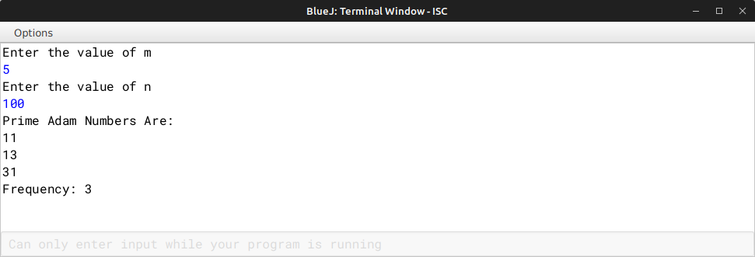

# Program 02

Write a program to declare a matrix A[][] of order (M x N) where 'M' is the number of rows and 'N' is the number of columns such that the value of 'M' must be greater than 0 and less than 10 and the value of 'N' must be greater than 2 and less than 6. Allow the user to input digits (0 - 7) only at each location, such that each row represents an octal number.

Example:

|  |  |  |  |
| --- | --- | --- | --- |
| 2 | 3 | 1 | (decimal equivalent of 1st row = 153 i.e. 2x82 + 3x81 + 1x80) |
| 4 | 0 | 5 | (decimal equivalent of 2nd row = 261 i.e. 4x82 + 0x81 + 5x80) |
| 1 | 5 | 6 | (decimal equivalent of 3rd row = 110 i.e. 1x82 + 5x81 + 6x80) |

Perform the following tasks on the matrix:

Display the original matrix.

Calculate the decimal equivalent for each row and display as per the format given below.

Test your program for the following data and some random data:

Example 1:

INPUT:

M = 1

N = 3

ENTER ELEMENTS FOR ROW 1: 1 4 4

OUTPUT:

FILLED MATRIX DECIMAL EQUIVALENT

1 4 4 100

Example 2:

INPUT:

M = 3

N = 4

ENTER ELEMENTS FOR ROW 1: 1 1 3 7

ENTER ELEMENTS FOR ROW 2: 2 1 0 6

ENTER ELEMENTS FOR ROW 3: 0 2 4 5

OUTPUT:

FILLED MATRIX DECIMAL EQUIVALENT

1 1 3 7 607

|  |  |  |  |  |
| --- | --- | --- | --- | --- |
| 2 | 1 | 0 | 6 | 1094 |
| 0 | 2 | 4 | 5 | 165 |

Example 3:

INPUT:

M = 3

N = 3

ENTER ELEMENTS FOR ROW 1: 2 4 8

OUTPUT:

INVALID INPUT

Example 4:

INPUT:

M = 4

N = 6

OUTPUT:

OUT OF RANGE

## 

## ALGORITHM

* Step-1:- START
* Step-2:- Create a class named as decimal.
* Step-3:- Create a function named as *dec_con* which takes an integer type array and two integer arguments and displays the decimal equivalent of the given number. In this function, first create a for loop (from 0 to row length of array) inside which create a variable named *decNum* and initialize it with 0. Inside the running for loop, start another for loop (from 0 to column length of array) and then store the sum value of the array indexes at [i][j] raised to the power (8,n-j-i) in the variable *decNum*, in this loop print the array element at [i][j]. After the inner for loop ends, print the value of *decNum*.
* Step-4:- Create a function named as main and call the method *dec_con* and pass the array and the number of rows and columns as arguments after taking the input of number of rows and columns and the array from the user.
* Step-5:- END

|  |  |  |  |
| --- | --- | --- | --- |
| VD TABLE |  | | |
| Sr. No. | Variable | Data Type | Description |
| 1 | i | int | To store the value of the |

loop variable

2 j int To store the value of the loop variable

3 m int To store the number of rows

4 n int To store the number of columns

5 decNum int To store the sum of decimal equivalent of the array indexes

6 a int To store the array elements

OUTPUT

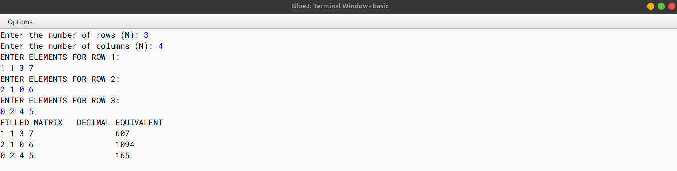

# Program 03

Write a program to accept a sentence which may be terminated by either '.', '?' or '!' only. The words are to be separated by a single blank space and are in UPPER CASE.

Perform the following tasks:

Check for the validity of the accepted sentence only for the terminating character.

Arrange the words in ascending order of their length. If two or more words have the

same length, then sort them alphabetically.

Display the original sentence along with the converted sentence.

Test your program for the following data and some random data:

Example 1:

INPUT:

AS YOU SOW SO SHALL YOU REAP.

OUTPUT:

AS YOU SOW SO SHALL YOU REAP. AS SO SOW YOU YOU REAP SHALL

Example 2:

INPUT:

SELF HELP IS THE BEST HELP.

OUTPUT:

SELF HELP IS THE BEST HELP. IS THE BEST HELP HELP SELF

Example 3: INPUT:

BE KIND TO OTHERS.

OUTPUT:

BE KIND TO OTHERS. BE TO KIND OTHERS

Example 4:

INPUT:

NOTHING IS IMPOSSIBLE#

OUTPUT:

INVALID INPUT

## 

## ALGORITHM

* Step-1 :- START
* Step-2 :- Create a class named as check.
* Step-3 :- Create a function named as *sen_check* and pass the string type parameter *sen*. In this function, create a string tokenizer object and pass the string sen and the delimiter as? .!,. Create a variable count to store the number of tokens. Create a string type array a[] and now using a for loop (from 0 to count) and store the tokens in the string type array a[]. Create a for loop (from 0 to the length of the array), start a inner loop (from 0 to a.length-1-i) and check whether a[j].compareTo(a[j+1])>0 is true then swap the adjacent elements. Create a for loop (from 0 to the length of the array), start a inner loop (from 0 to a.length-1-i) and check whether a[j].length() > a[j + 1].length(), if true then swap them if they are not in the desired order. Now print the sorted array.
* Step-4 :- Create a function named as main. In this function, create a string type variable *sen* and store the sentence in it (user input). Call the function *sen_check* and pass the string *sen*  as the parameter.

|  |  |  |  |  |
| --- | --- | --- | --- | --- |
| * Step-5 :- END   VD TABLE |  | | | |
|  | Sr. No. | Variable | Data Type | Description |
|  | 1 | i | int | To store the value of the loop variable |
|  | 2 | j | int | To store the value of the loop variable |
|  | 3 | count | int | To store the number of tokens |
|  | 4 | a[] | String | To store the tokens |
|  | 5 | sen | String | To store the sentence |
|  | 6 | temp | String | To store the temporary value |
|  | 7 | last | char | To store the last character of the sentence |
|  | 8 | len | int | To store the length of the sentence |
| OUTPUT |  |  |  |  |

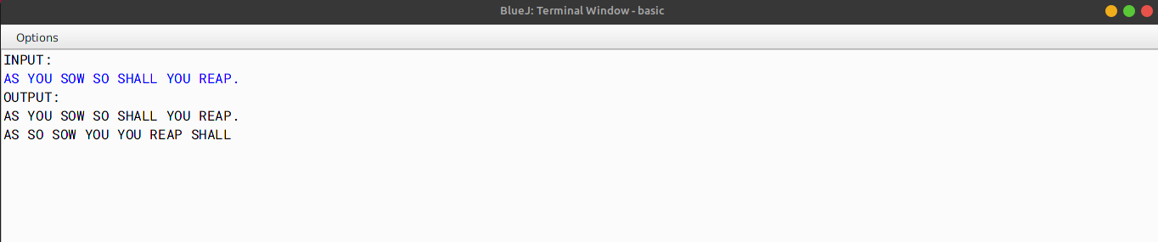

# Program 04

Design a program to accept a day number (between 1 and 366), year (in 4 digits) from the user to generate and display the corresponding date. Also, accept 'N' (1 <= N <= 100) from the user to compute and display the future date corresponding to 'N' days after the generated date. Display an error message if the value of the day number, year and N are not within the limit or not according to the condition specified.

Test your program with the following data and some random data: Example 1

INPUT:

DAY NUMBER: 255

YEAR: 2018

DATE AFTER (N DAYS): 22

OUTPUT:

DATE: 12TH SEPTEMBER, 2018

DATE AFTER 22 DAYS: 4TH OCTOBER, 2018

Example 2 INPUT:

DAY NUMBER: 360

YEAR: 2018

DATE AFTER (N DAYS): 45

OUTPUT:

DATE: 26TH DECEMBER, 2018

DATE AFTER 45 DAYS: 9TH FEBRUARY, 2019

Example 3 INPUT:

DAY NUMBER: 500

YEAR: 2018

DATE AFTER (N DAYS): 33

OUTPUT:

DAY NUMBER OUT OF RANGE

Example 4

INPUT:

DAY NUMBER: 150

YEAR: 2018

DATE AFTER (N DAYS): 330

OUTPUT:

DATE AFTER (N DAYS) OUT OF RANGE

## 

## ALGORITHM

* Step-1 :- START
* Step-2 :- Create a class named as days.
* Step-3 :- Create a method named as main and declare the Scanner class. Declare the variables- n, day, year- of integer type to store the number of days, calculated days and year respectively. Create an array named a of integer type in order to store the names of the 12 months order wise. Check whether the year entered is a leap year or not, if true then store the number of days in the month of February as 29 else store it as 28. Using multiple for-loops store the calculated days in the variable day and the year in the variable year. Finally print the calculated date, month and y
* Step-4 :- END

|  |  |  |  |  |
| --- | --- | --- | --- | --- |
| VD TABLE |  | | | |
|  | Sr. No. | Variable | Data Type | Description |
|  | 1 | n | int | To store the number of days |
|  | 2 | day | int | To store the days |
|  | 3 | year | int | To store the year |
|  | 4 | a | int[] | To store the names of the 12 months orderwise |
|  | 5 | i | int | Used in for-loop |
|  | 6 | j | int | Used in for-loop |
|  | 7 | k | int | Used in for-loop |
|  | 8 | nday | int | To store the calculated day number |
|  | 9 | date | int | To store the calculated date |
| OUTPUT |  |  |  |  |

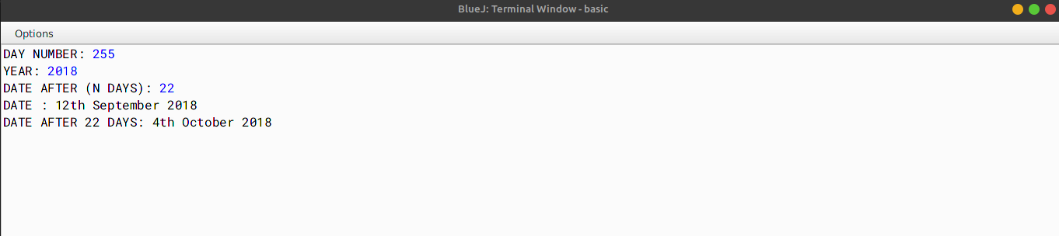

# Program 05

Write a program to declare a single-dimensional array a[] and a square matrix b[][] of size N, where N > 2 and N < 10. Allow the user to input positive integers into the single dimensional array.

Perform the following tasks on the matrix:

Sort the elements of the single-dimensional array in ascending order using any standard sorting technique and display the sorted elements.

Fill the square matrix b[][] in the following format:

If the array a[] = {5, 2, 8, 1} then, after sorting a[] = {1, 2, 5, 8}

Then, the matrix b[][] would fill as below:

1 2 5 8

1 2 5 1

1 2 1 2

1 1 2 1

Display the filled matrix in the above format.

Test your program for the following data and some random data: Example 1

INPUT:

N = 3

ENTER ELEMENTS OF SINGLE DIMENSIONAL ARRAY: 3 1 7

OUTPUT:

SORTED ARRAY: 1 3 7

FILLED MATRIX

1 3 7

1 3 1

1 1 3

Example 2 INPUT:

N = 13

OUTPUT:

MATRIX SIZE OUT OF RANGE

Example 3 INPUT:

N = 5

ENTER ELEMENTS OF SINGLE DIMENSIONAL ARRAY: 10 2 5 23 6

OUTPUT:

SORTED ARRAY: 2 5 6 10 23 FILLED MATRIX

2 5 6 10 23

2 5 6 10 2

2 5 6 2 5

2 5 2 5 6

2 2 5 6 10

## 

## ALGORITHM

* Step-1 :- START
* Step-2 :- Create a class named as sort.
* Step-3 :- Create a method named as sort and pass the integer type array a[] as parameter. In this function, create a for loop (from 0 to the length of the array), start a inner loop (from 0 to a.length-1-i) and check whether a[j] > a[j + 1], if true then swap them if they are not in the desired order.
* Step-4 :- Create a method named as main. In this function, create an integer type array a[] and store the elements in it (user input). Call the function sort and pass the array a[] as the parameter. Print the sorted array. Create a 2-Dimensional array b[][] and store the elements of sorted array a[] in the required pattern using for-loops. Now print the 2-Dimensional array b[][].
* Step-5 :- END

|  |  |  |  |
| --- | --- | --- | --- |
| VD TABLE |  | | |
| Sr. No. | Variable | Data Type | Description |
| 1 | i | int | To store the value of the |

loop variable

2 j int To store the value of the loop variable

3 a int[] To store the elements of the array

4 b int[][] To store the elements of the array in the required pattern

5 n int To store the size of the array

6 temp int To store the temporary value

7 k int To store the value of the loop variable

8 r int To store the value of the loop variable

OUTPUT

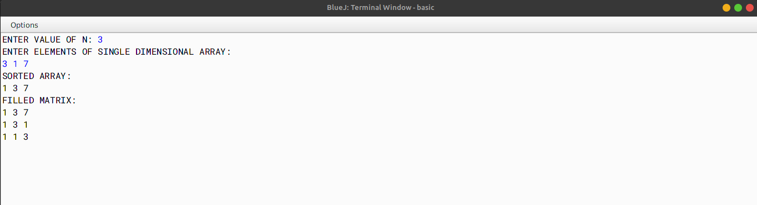

# Program 06

Write a program to accept a sentence which may be terminated by either.,? or! only. The words are to be separated by a single blank space and are in uppercase.

Perform the following tasks:

1. Check for the validity of the accepted sentence.
2. Convert the non-palindrome words of the sentence into palindrome words by concatenating the word by its reverse (excluding the last character).

Example:

The reverse of the word HELP would be LEH (omitting the last alphabet) and by concatenating both, the new palindrome word is HELPLEH. Thus, the word HELP becomes HELPLEH.

Note: The words which end with repeated alphabets, for example ABB would become ABBA and not ABBBA and XAZZZ becomes XAZZZAX.

[Palindrome word: Spells same from either side. Example: DAD, MADAM etc.]

1. Display the original sentence along with the converted sentence.

Test your program for the following data and some random data: Example 1

INPUT:

THE BIRD IS FLYING.

OUTPUT:

THE BIRD IS FLYING.

THEHT BIRDRIB ISI FLYINGNIYLF

Example 2 INPUT:

IS THE WATER LEVEL RISING?

OUTPUT:

IS THE WATER LEVEL RISING?

ISI THEHT WATERETAW LEVEL RISINGNISIR

Example 3 INPUT:

THIS MOBILE APP LOOKS FINE.

OUTPUT:

THIS MOBILE APP LOOKS FINE.

THISIHT MOBILELIBOM APPA LOOKSKOOL FINENIF

Example 4

INPUT:

YOU MUST BE CRAZY#

OUTPUT:

INVALID INPUT

## 

## ALGORITHM

* Step-1 :- START
* Step-2 :- Create a class named as “palin”.
* Step-3 :- Create a method named as *isPalindrome* and pass a string named word as a parameter. In this function check whether the string is palindrome or not.
* Step-4 :- Create a method named as *makePalindrome* and pass a string named *word*  as a parameter. In this function, declare variables to store length and the last character of the string *word* in *len* and last Char respec- tively. Using a StringBuffer class and a for-loop, append the string word to the StringBuffer object sb and then append the last character of the string word to the StringBuffer object sb. Then, return the StringBuffer object sb as a string.
* Step-5 :- Create a method named as main. In this function, using Scanner class take the input of the string Str as input. Then, call the method *isPallindrome* and pass the string word as a parameter. If the method returns true, then print the string Str. Then, call the method *makePalindrome* and pass the string word as a parameter. Then, print the string returned by the method *makePalindrome*.
* Step-6 :- END

|  |  |  |  |
| --- | --- | --- | --- |
| VD TABLE |  | | |
| Sr. No. | Variable | Data Type | Description |
| 1 | Str | String | To store the input string |
| 2 | word | String | To store the words of the |

string

3 str String To store the string without front and back spaces

4 len int To store the length of the string

5 lastChar char To store the last character of the string

6 i int Used in for-loop

7 isPalindrome boolean To check whether the word is pallindrome or not

8 palin boolean To check whether the word is pallindrome or not

9 palinWord String To store the string returned by the method

makePalindrome

10 convertedStr String To store the converted string

OUTPUT

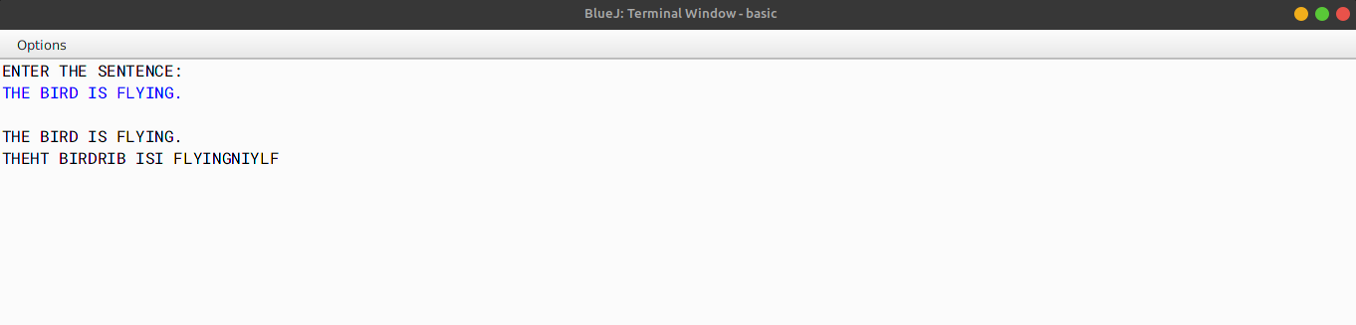

# Program 07

A Goldbach number is a positive even integer that can be expressed as the sum of two odd primes.

Note: All even integer numbers greater than 4 are Goldbach numbers. Example:

6 = 3 + 3

10 = 3 + 7

10 = 5 + 5

Hence, 6 has one odd prime pair 3 and 3. Similarly, 10 has two odd prime pairs, i.e. 3 and 7, 5 and 5.

Write a program to accept an even integer 'N' where N > 9 and N < 50. Find all the odd prime pairs whose sum is equal to the number 'N'.

Test your program with the following data and some random data: Example 1

INPUT:

N = 14

OUTPUT:

PRIME PAIRS ARE: 3, 11

7, 7

Example 2 INPUT:

N = 30

OUTPUT:

PRIME PAIRS ARE: 7, 23

11, 19

13, 17

Example 3

INPUT:

N = 17

OUTPUT:

INVALID INPUT. NUMBER IS ODD.

Example 4 INPUT:

N = 126

OUTPUT:

INVALID INPUT. NUMBER OUT OF RANGE.

## 

## ALGORITHM

* Step-1 :- START
* Step-2 :- Create a class named as “*Goldbach”*.
* Step-3 :- Create a method named as even of type boolean and pass an integer named n as a parameter. In this function, check whether the number is even or not.
* Step-3 :- Create a method named as *odd_prime* of type boolean and pass an integer named n as a parameter. In this function, first call the function even and check whether the number is even or not. If the number is not even then check whether the number is prime or not.
* Step-4 :- Create a method named as main. In this function, first take an integer input from the user and store it in a variable named n. Now call the function even and check the required, then call the function *odd_prime* and check whether the number is prime or not. Create two for-loops (from 1 to n and from 1 to i(variable of the outer loop)), now check whether the both the loop variables is prime or not by calling the function *odd_prime* and passing the loop variable as parameter. If the number is prime then print the number.
* Step-5 :- END

## VD TABLE

Sr. No. Variable Data Type Description

|  |  |  |  |  |
| --- | --- | --- | --- | --- |
|  | 1 | n | int | To store the input number |
| 2 | i | int | To store the value of the outer loop |
| 3 | j | int | To store the value of the inner loop |
| 4 | k | int | Used as counter variable |
| 5 | c | int | Used as counter variable |
| OUTPUT |  |  |  |  |

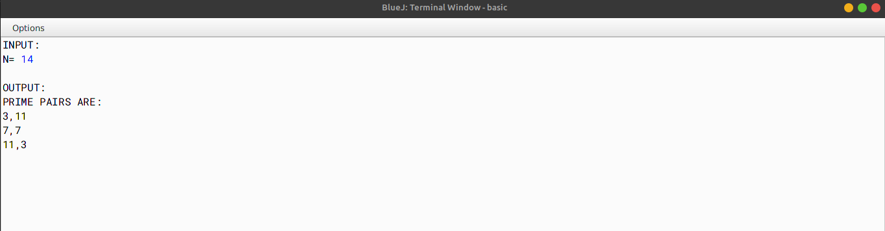

# Program 08

Write a program to declare a matrix a[][] of order (m n) where 'm' is the number of rows and 'n' is the number of columns such that the values of both 'm' and 'n' must be greater than 2 and less than 10. Allow the user to input integers into this matrix. Perform the following tasks on the matrix:

Display the original matrix.

Sort each row of the matrix in ascending order using any standard sorting technique. Display the changed matrix after sorting each row.

Test your program for the following data and some random data: Example 1

INPUT:

M = 4

N = 3

ENTER ELEMENTS OF MATRIX: 11 -2 3

5 16 7

9 0 4

3 1 8

OUTPUT:

ORIGINAL MATRIX

11 -2 3

5 16 7

9 0 4

3 1 8

MATRIX AFTER SORTING ROWS

-2 3 11

5 7 16

0 4 9

1 3 8

Example 2

INPUT:

M = 3

N = 3

ENTER ELEMENTS OF MATRIX 22 5 19

7 36 12

9 13 6

OUTPUT:

ORIGINAL MATRIX

22 5 19

7 36 12

9 13 6

MATRIX AFTER SORTING ROWS 5 19 22

7 12 36

6 9 13

Example 3 INPUT:

M = 11

N = 5

OUTPUT:

MATRIX SIZE OUT OF RANGE.

## 

## ALGORITHM

* Step-1 :- START
* Step-2 :- Create a class named as sort.
* Step-3 :- Create a method named as main. In this function, create variables named as m and n to store the number of rows and columns of the matrix respectively. Now check whether number of rows and columns are valid or not. If not, then print Invalid Input and terminate the program. Otherwise, continue. Create a 2D array named as a[][] of size m and n and using for loops take the array input. Now print the original array. Now create two for loops to traverse the array. In the inner loop, check whether the current element is greater than the next element or not. If yes, then swap the elements. Now print the sorted array.
* Step-4 :- END

## VD TABLE

Sr. No. Variable Data Type Description

|  |  |  |  |  |
| --- | --- | --- | --- | --- |
|  | 1 | m | int | To store the number of rows of the matrix |
| 2 | n | int | To store the number of columns of the matrix |
| 3 | arr | int[][] | To store the elements of the matrix |
| 4 | i | int | To store the value of the current row |
| 5 | j | int | To store the value of the current column |
| 6 | t | int | To store the value of the current element |
| OUTPUT |  |  |  |  |

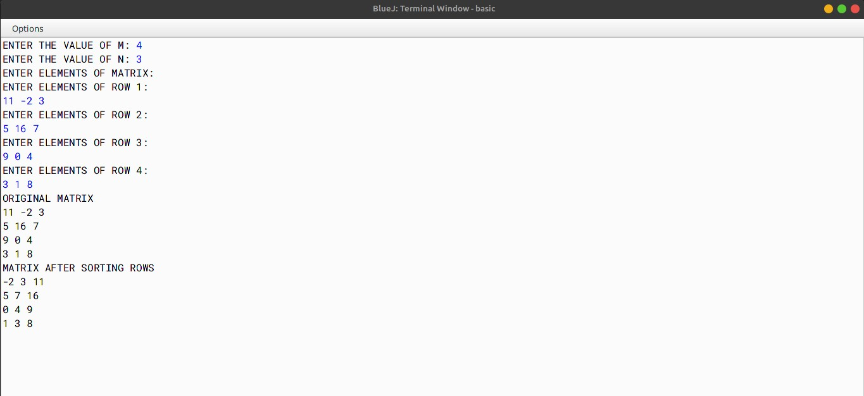

# Program 09

The names of the teams participating in a competition should be displayed on a banner vertically, to accommodate as many teams as possible in a single banner. Design a program to accept the names of N teams, where 2 < N < 9 and display them in vertical order, side by side with a horizontal tab (i.e. eight spaces).

Test your program for the following data and some random data: Example 1

INPUT:

N = 3

Team 1: Emus Team 2: Road Rols Team 3: Coyote

OUTPUT:

E R C

m o o

u a y

s d o

t

R e

ols

Example 2 INPUT:

N = 4

Team 1: Royal

Team 2: Mars Team 3: De Rose Team 4: Kings

OUTPUT:

|  |  |  |  |
| --- | --- | --- | --- |
| R | M | D | K |
| o | a | e | i |
| y | r |  | n |
| a | s | R  o  s  e | g  s |

Example 3 INPUT:

N = 10

OUTPUT:

INVALID INPUT

## 

## ALGORITHM

* Step-1 :- START
* Step-2 :- Create a class named as banner.
* Step-3 :- Create a method named as main. In this function, create a variable named as n to store the value of the numbers of team participating. Create an array of type String named as teams of size n, create another variable of type int named as *highLen* and initialize it to 0. Now using the for loop take the input of the names of the teams and store it in the array teams, after each input check if the length of the input is greater than the value of *highLen* if yes then update the value of *highLen* to the length of the input. Now create a nested for loop and within which compare the variable of loop 1 with *len* (which stores the length of the string at the current index), if true print a blank line else print the letter of the string at the current index. Repeat the process until the loop ends.
* Step-4 :- END

VD TABLE

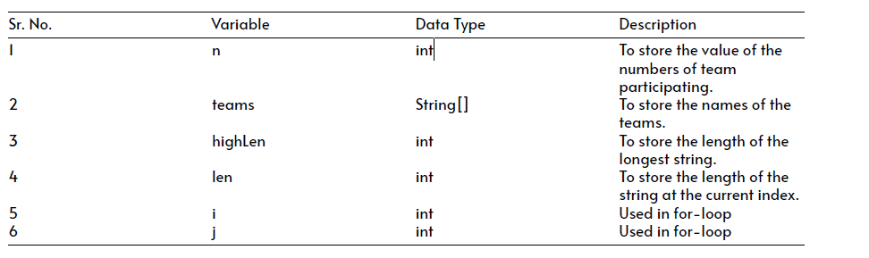

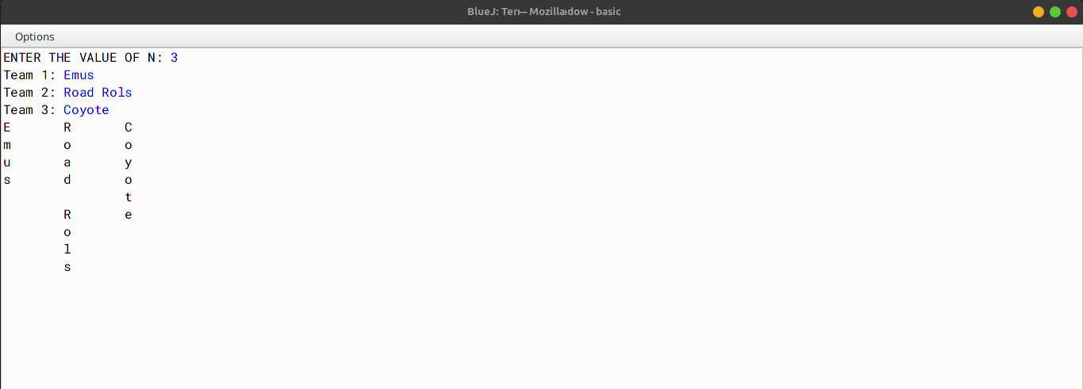OUTPUT

# Program 10

A company manufactures packing cartons in four sizes, i.e. cartons to accommodate 6 boxes, 12 boxes, 24 boxes and 48 boxes. Design a program to accept the number of boxes to be packed (N) by the user (maximum up to 1000 boxes) and display the break-up of the cartons used in descending order of capacity (i.e. preference should be given to the highest capacity available, and if boxes left are less than 6, an extra carton of capacity 6 should be used.)

Test your program with the following data and some random data: Example 1

INPUT:

N = 726

OUTPUT:

48 * 15 = 720

6 * 1 = 6

Remaining boxes = 0

Total number of boxes = 726 Total number of cartons = 16

Example 2 INPUT:

N = 140

OUTPUT:

48 * 2 = 96

24 * 1 = 24

12 * 1 = 12

6 * 1 = 6

Remaining boxes = 2 * 1 = 2 Total number of boxes = 140 Total number of cartons = 6

Example 3 INPUT:

N = 4296

OUTPUT:

INVALID INPUT

## 

## ALGORITHM

* Step-1 :- START
* Step-2 :- Create a class named as boxes.
* Step-3 :- Create a method named as main. In this function, create a variable named as n to store the number of boxes. Check if the number of boxes is greater than 0 and less than 1000 or not, if true then print Invalid Input and exit the program. Create an array named as *cartonSizes* to store the various sizes of the boxes. Create a for-loop (from 0 to length of *cartonSizes*) inside which calculate and print the volume of each box size. Print the total volume of all the boxes.
* Step-4 :- END

|  |  |  |  |  |
| --- | --- | --- | --- | --- |
| VD TABLE |  | | | |
|  | Sr. No. | Variable | Data Type | Description |
|  | 1 | n | int | To store the number of boxes |
|  | 2 | cartonSizes | int[] | To store the various sizes of the boxes |
|  | 3 | i | int | To store the index of the array |
|  | 4 | cartonCount | int | To store the volume of each box size |
|  | 5 | total | int | To store the total number of all the boxes |
|  | 6 | t | int | Used as temporary variable |
| OUTPUT |  |  |  |  |

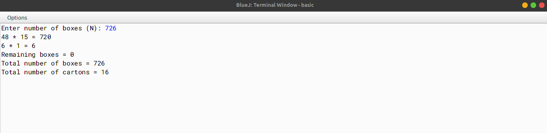

# Program 11

The result of a quiz competition is to be prepared as follows:

The quiz has five questions with four multiple choices (A, B, C, D), with each question carrying 1 mark for the correct answer. Design a program to accept the number of participants N such that N must be greater than 3 and less than 11. Create a double- dimensional array of size (Nx5) to store the answers of each participant row-wise. Calculate the marks for each participant by matching the correct answer stored in a single- dimensional array of size 5. Display the scores for each participant and also the participant(s) having the highest score.

Example: If the value of N = 4, then the array would be:

|  |  |  |  |  |  |
| --- | --- | --- | --- | --- | --- |
|  | Q1 | Q2 | Q3 | Q4 | Q5 |
| Participant 1 | A | B | B | C | A |
| Participant 2 | D | A | D | C | B |
| Participant 3 | A | A | B | A | C |
| Participant 4 | D | C | C | A | B |
|  |  |  |  |  |  |

Key to the question: D C C B A Note: Array entries are line fed (i.e. one entry per line)

Test your program for the following data and some random data. Example 1

INPUT:

N = 5

Participant 1 D A B C C Participant 2 A A D C B Participant 3 B A C D B Participant 4 D A D C B Participant 5 B C A D D Key: B C D A A

OUTPUT:

Scores:

Participant 1 = 0

Participant 2 = 1

Participant 3 = 1

Participant 4 = 1

Participant 5 = 2

Highest Score: Participant 5

Example 2

INPUT:

N = 4

Participant 1 A C C B D Participant 2 B C A A C Participant 3 B C B A A Participant 4 C C D D B Key: A C D B B

OUTPUT:

Scores:

Participant 1 = 3

Participant 2 = 1

Participant 3 = 1

Participant 4 = 3

Highest Score: Participant 1

Participant 4

Example 3: INPUT:

N = 12

OUTPUT:

INPUT SIZE OUT OF RANGE.

## 

## ALGORITHM

* Step-1 :- START
* Step-2 :- Create a class named as quiz.
* Step-3 :- Create a method named as main. In this function, declare a Scanner variable named as sc and initialize it with new Scanner(System.in). Now using the sc variable, take the input of the number of participants in the quiz in a variable named as n. Create two arrays named as answers[][] and key[] of size n and of type char respectively. Using two for loops (from 0 to n-1), take the input of the answers of the participants in the answers[][] array and the correct answers in the key[] array. Now, using two for loops (from 0 to n-1), compare the answers of the participants with the correct answers storing them in an array score[] and print the number of correct answers of each participant. Now, compare each score with the maximum score and print the number of participants who have scored the maximum score. Now Print the number of participants who have scored the maximum score.
* Step-4 :- END

|  |  |  |  |
| --- | --- | --- | --- |
| VD TABLE |  | | |
| Sr. No. | Variable | Data Type | Description |
| 1 | n | int | Number of participants in |

the quiz

2 answers[][] char Array to store the answers of the participants

3 key[] char Array to store the correct answers

4 score[] int Array to store the number of correct answers of each participant

5 hscore int Variable to store the maximum score

6 i int To store the index of the array

7 j int To store the index of the array

OUTPUT

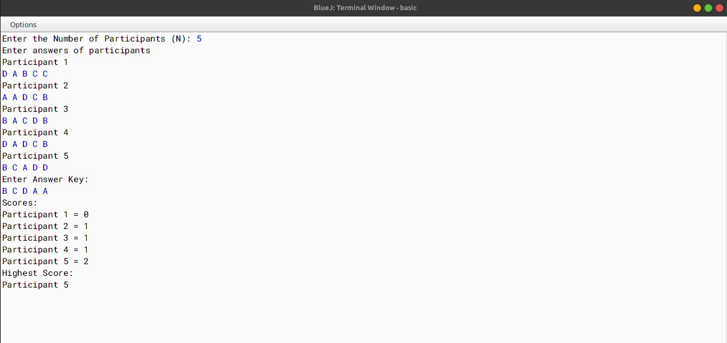

# Program 12

Caesar Cipher is an encryption technique which is implemented as ROT13 ('rotate by 13 places'). It is a simple letter substitution cipher that replaces a letter with the letter 13 places after it in the alphabets, with the other characters remaining unchanged.

|  |  |  |  |  |  |  |  |  |  |  |
| --- | --- | --- | --- | --- | --- | --- | --- | --- | --- | --- |
| ROT13  A/a | B/b | C/c | D/d | E/e | F/f | G/g | H/h | I/i | J/j K/k | L/l |
|  | M/m |  |  |  |  |  |  |  |  |  |
| N/n | O/o Z/z | P/p | Q/q | R/r | S/s | T/t | U/u | V/v | W/w X/x | Y/y |

Write a program to accept a plain text of length L, where L must be greater than 3 and less than 100.

Encrypt the text if valid as per the Caesar Cipher.

Test your program with the sample data and some random data.

Example 1

INPUT:

Hello! How are you?

OUTPUT:

The cipher text is:

Uryyb! Ubj ner lbh? Example 2

INPUT:

Encryption helps to secure data.

OUTPUT:

The cipher text is:

Rapelcgvba urycf gb frpher qngn.

Example 3

INPUT:

You

OUTPUT:

INVALID LENGTH

## 

## ALGORITHM

* Step-1 :- START
* Step-2 :- Create a class named as CaesarCipher.
* Step-3 :- Create a method named as main. In this function, create a variable named as text and assign a string value to it from the user (using Scanner class) which stores the plain text. Create a StringBuffer object named as sb. Create a for loop (from 0 to length of the string), inside this create a variable ch of type char and store each character of string text, now check the condition if the character ch is between A-M, if true then append((char)(ch+13)) to sb, else if the character ch is between N-Z, if true then append((char)(ch-13)) to sb, else append(ch) to sb. Now store the value of sb in a string variable named as cipher and print it.
* Step-4 :- END

|  |  |  |  |  |
| --- | --- | --- | --- | --- |
| VD TABLE |  | | | |
|  | Sr. No. | Variable | Data Type | Description |
|  | 1 | text | String | Stores the plain text |
|  | 2 | sb | StringBuffer | Stores the cipher text |
|  | 3 | ch | char | Stores the character of the string |
|  | 4 | cipher | String | Stores the cipher text |
|  | 5 | i | int | Stores the index of the string |
|  | 6 | len | int | Stores the length of the string |
| OUTPUT |  |  |  |  |

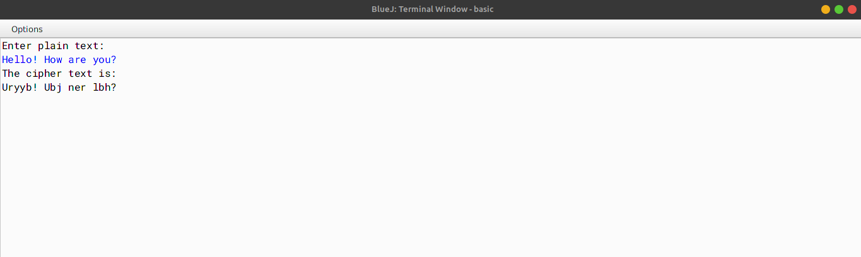

# Program 13

Design a class "Check" which checks whether a word is a palindrome or not. (Palindrome words are those which spell the same from either ends).

Example: MADAM, LEVEL etc.

The details of the members of the class are given below:

Class name: Check

Data members / instance variables:

wrd : stores a word

len : to store the length of the word

Methods / Member functions:

Check( ) : default constructor

void acceptword( ) : to accept the word

boolean palindrome ( ) : checks and returns true if the word is a palindrome otherwise returns false

void display( ) : displays the word along with an appropriate message

Specify the class "Check" giving details of the constructor, void acceptword( ), boolean palindrome( ) and void display( ).

Define the main( ) function to create an object and call the functions accordingly to enable the task.

## 

## ALGORITHM

* Step-1 :- START
* Step-2 :- Create a class named as "Check".
* Srep-3 :- Create a constructor to initialize the instance variable String wrd with null, int len with 0.
* Step-4 :- Create a void method "acceptword()" to input a word in wrd and and count the length of the word and store in len.
* Step-5 :- Create a boolean method "palindrome()" to check if the word is palindrome or not by checking the first and the last leter of the word i.e. palinedrome words will have first and last letter common.
* Step-6 :- Create a void method "display()" to print if the entered word is palindrome or not by checking the result of the boolean "palindrome()".
* Step-7 :- Create the "main" method to create a object and call "acceptword()" and "display()" methods.
* Step-8 :- END

## VD TABLE

Sr. No. Variable Data Type Description

|  |  |  |  |  |
| --- | --- | --- | --- | --- |
|  | 1 | wrd | String | Stores the input word |
| 2 | len | int | Stores the len of the input word |
| 3 | i | int | To iterate the for-loop for checking palindrome |
| 4 | j | int | To iterate the for-loop for checking palindrome |
| OUTPUT |  |  |  |  |

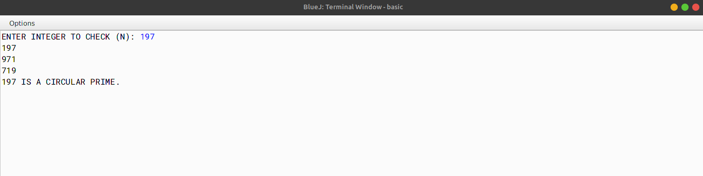

# Program 14

Design a class "Toggle" which toggles a word by converting all upper-case alphabets to lower case and vice versa.

Example: The word mOTivATe becomes MotIVatE The details of the members of the class are given below:

Class name : Toggle

Data members/instance variables:

str : stores a word

newstr : stores the toggled word len : to store the length of the word

Methods/Member functions:

Toggle( ) : default constructor

void readword( ) : to accept the word

void toggle ( ) : converts the upper case alphabets to lower case and all lower case alphabets to upper case and stores it in newstr

void display( ) : displays the original word along with the toggled word

Specify the class Toggle giving details of the constructor, void readword( ), void toggle( ) and void display( ).

Define the main( ) function to create an object and call the functions accordingly to enable the task.

## 

## ALGORITHM

* Step-1 :- START
* Step-2 :- Create a class named as "Toggle".
* Srep-3 :- Create a constructor to initialize the instance variable String str and newstr with null, int len with 0.
* Step-4 :- Create a void method "readword()" to input a word in str and and count the length of the word and store in len.
* Step-5 :- Create a void method "toggle()" to go through the whole word and check if the letter is uppercase or lowercase and convert it to its opposite case.
* Step-6 :- Create a void method "display()" to print the original and the new word.
* Step-7 :- Create the "main" method to create a object and call "readword()", "toggle()" and "display()" meth- ods.
* Step-8 :- END

|  |  |  |  |  |
| --- | --- | --- | --- | --- |
| VD TABLE |  | | | |
|  | Sr. No. | Variable | Data Type | Description |
|  | 1 | str | String | Stores the input word |
|  | 2 | newstr | String | Stores the new toggled word |
|  | 3 | len | int | Stores the len of the input word |
|  | 4 | i | int | To iterate the for-loop for going through the word |

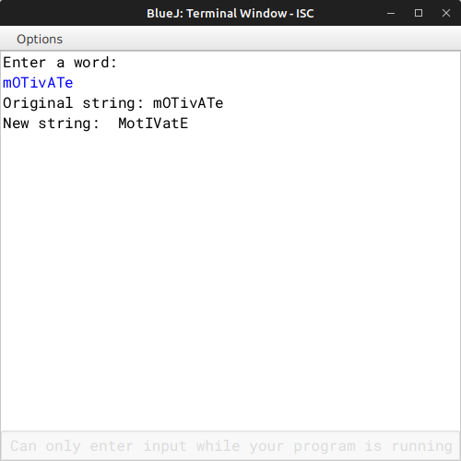OUTPUT

# Program 15

A class Fibo has been defined to generate the Fibonacci series 0, 1, 1, 2, 3, 5, 8, 13, ....... (Fibonacci series are those in which the sum of the previous two terms is equal to the next term).

Some of the members of the class are given below:

Class name: Fibo

Data member/instance variable:

start: integer to store the start value end: integer to store the end value

Member functions/methods:

Fibo( ) : default constructor

void read( ) : to accept the numbers

int fibo(int n) : return the nth term of a Fibonacci series using recursive technique

void display( ) : displays the Fibonacci series from start to end by invoking the function fibo()

Specify the class Fibo, giving details of the Constructor, void read(), int fibo(int), and void display( ).

Define the main() function to create an object and call the functions accordingly to enable the task.

## 

## ALGORITHM

* Step-1 :- START
* Step-2 :- Create a class named as "Fibo".
* Srep-3 :- Create a constructor to initialize the instance variable int start and end with 0.
* Step-4 :- Create a void method "read()" to input the start and end value for the series.
* Step-5 :- Create a int method "fibo(int n)" to return the nth term of a Fibonacci series using recursive technique.
* Step-6 :- Create a void method "display()" to displays the Fibonacci series from start to end by invoking the function fibo().
* Step-7 :- Create the "main" method to create a object and call "read" and "display" methods.
* Step-8 :- END

|  |  |  |  |
| --- | --- | --- | --- |
| VD TABLE |  | | |
| Sr. No. | Variable | Data Type | Description |
| 1 | start | int | Store the start value |
| 2 | end | int | Store the end value |
| 3 | n | int | Formal parameter for |

method fibo()

4 i int To iterate the for-loop for printing the series int display()

OUTPUT

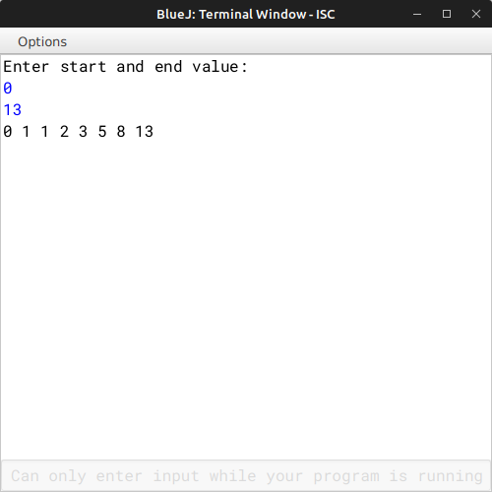

# Program 16

A class Gcd has been defined to find the Greatest Common Divisor of two integer numbers.

Some of the members of the class are given below:

Class name: Gcd

Data member/instance variable:

num1 : integer to store the first number num2 : integer to store the second number

Member functions/methods:

Gcd( ) : default constructor

void accept( ) : to accept the numbers

int gcd(int x,int y) : return the GCD of the two number x and y using recursive technique void display( ) : displays the result with an appropriate message

Specify the class Gcd, giving details of the Constructor, void accept( ), int gcd(int,int), and void display( ).

Define the main() function to create an object and call the functions accordingly to enable the task.

## 

## ALGORITHM

* Step-1 :- START
* Step-2 :- Create a class named as "Gcd".
* Srep-3 :- Create a constructor to initialize the instance variable int num1 and num2 with 0.
* Step-4 :- Create a void method "accept" to accept two nos. in num1 and num2 respectively.
* Step-5 :- Create a int method "gcd" to calculate the gcd of the two nos. using recursive technique.
* Step-6 :- Create a void method "display" to print the gcd of the two nos.
* Step-7 :- Create the "main" method to create a object and call "accept" and "display" methods.

|  |  |  |  |
| --- | --- | --- | --- |
| * Step-8 :- END   VD TABLE |  | | |
| Sr. No. | Variable | Data Type | Description |
| 1 | num1 | int | Stores the first no. |
| 2 | num2 | int | Stores the second no. |
| 3  4  5 | x  y temp | int  int int | Formal parameter for function gcd() Formal parameter for function gcd()  Temporary variable for |
|  |  |  | swapping num1 and num2 |
|  |  |  | in display(), if num1 is |
|  |  |  | smaller than num2 |

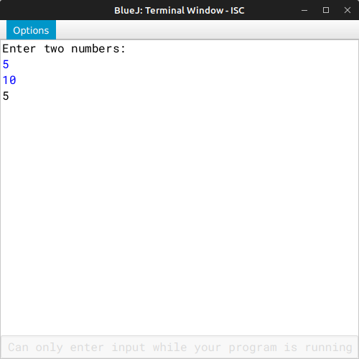 OUTPUT

# Program 17

Design a class ArmNum to check if a given number is an Armstrong number or not.

[A number is said to be Armstrong if sum of its digits raised to the power of length of the number is equal to the number]

Example: 371 = 3 + 7 + 1

1634 = 1 + 6 + 3 + 4

54748 = 5 + 4 + 7 + 4 + 8

Thus 371, 1634 and 54748 are all examples of Armstrong numbers. Some of the members of the class are given below:

Class name: ArmNum

Data members / instance variables:

n : to store the number

l : to store the length of the number

Methods / Member functions:

ArmNum(int nn) : parameterized constructor to initialize the data member n=nn

int sum_pow(int i) : returns the sum of each digit raised to the power of the length of the number using recursive technique eg. 34 will return 32 + 42 (as the length of the number is 2)

void isArmstrong( ) : checks whether the given number is an Armstrong number by invoking the function sum_pow( ) and displays the result with an appropriate message

Specify the class ArmNum giving details of the constructor(), int sum_pow(int) and void isArmstrong( ).

Define a main( ) function to create an object and call the functions accordingly to enable the task.

## 

## ALGORITHM

* Step-1 :- START
* Step-2 :- Create a class named as "ArmNum".
* Srep-3 :- Create a parameterized constructor to initialize the instance variable int n with int num.
* Step-4 :- Create a int method "sum_pow(int i)" calculate the sum of the power of the digit to the length of digit, using recursive technique.
* Step-5 :- Create a void method "isArmstrong()" to check the no. is Armstorm and prints the appropriate mes- sage.
* Step-6 :- Create the "main" method to input the no. and create a object and call "isArmstrong()" methods.
* Step-7 :- END

|  |  |  |  |
| --- | --- | --- | --- |
| VD TABLE |  | | |
| Sr. No. | Variable | Data Type | Description |
| 1 | n | int | Stores the no. |
| 2 | l | int | Stores the length of the no. |
| 3 | nn | int | Parameter for the  parameterized construtor |

ArmNum(int nn)

4 c int Looping variable to count the length of the no.

5 i int Formal parameter for sum_pow(int i)

## OUTPUT

## 

# Program 18

Design a class MatRev to reverse each element of a matrix. Example:

|  |  |  |
| --- | --- | --- |
| 72 | 371 | 5 |
| 12 | 6 | 426 |
| 5 | 123 | 94 |

|  |  |  |
| --- | --- | --- |
| 27 | 173 | 5 |
| 21 | 6 | 624 |
| 5 | 321 | 49 |

becomes

Some of the members of the class are given below:

Class name : MatRev

Data members/instance variables:

arr[ ][ ] : to store integer elements

m : to store the number of rows

n : to store the number of columns Member functions/methods:

MatRev(int mm, int nn) : parameterised constructor to initialise the

data

members m = mm and n = nn

void fillarray( ) : to enter elements in the array

int reverse(int x) : returns the reverse of the number x

void revMat( MatRev P) : reverses each element of the array of the

parameterized object and stores it in the array of the current object

void show( ) : displays the array elements in matrix form

Define the class MatRev giving details of the constructor( ), void fillarray( ), int reverse(int), void revMat(MatRev) and void show( ). Define the main( ) function to create objects and call the functions accordingly to enable the task.

## 

## ALGORITHM

* Step-1 :- START
* Step-2 :- Create a class named as "MatRev".
* Srep-3 :- Create a parameterized constructor to initialize the instance variable int m and n and also initialize arr with m & n.
* Step-4 :- Create a void method "fillArray()" to accept elements in the array arr[m][n].
* Step-5 :- Create a int method "reverse(int x)" to reverse any no.
* Step-6 :- Create a void method "revMat(MatRev p)" to reverse the matrix with the help of "reverse(int x)".
* Step-7 :- Create a void method "show()" to display a matrix.
* Step-8 :- Create the "main" method to input the no. of rows and columns and create two objects obj1 & obj2 then take input in one array and fill the other array with the reverse integers of the first array, then print both.
* Step-9 :- END

OUTPUT

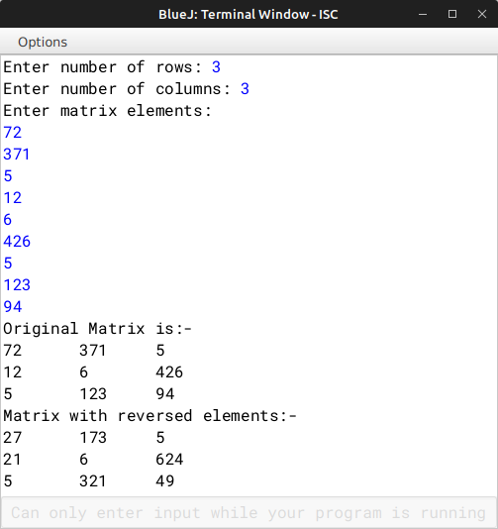

|  |  |  |  |
| --- | --- | --- | --- |
| VD TABLE |  | | |
| Sr. No. | Variable | Data Type | Description |
| 1 | arr[][] | int | A array to store integers in |
| 2 | m | int | m rows and n columns  Stores no. of rows |
| 3 | n | int | Stores no. of columns |
| 4 | mm | int | Parameter for no. of rows |
| 5 | nn | int | in MatRev(int mm, int nn)  Parameter for no. of |
| 6 | i | int | columns in MatRev(int mm, int nn)  Looping variable in |
| 7 | j | int | fillArray() & show()  Looping variable in |
| 8 | rev | int | fillArray() & show()  Store the reverse of a no. |
| 9 | x | int | Store the user input no. of |
| 10 | y | int | rows.  Store the user input no. of |
|  |  |  | columns. |
|  |  |  |  |

# Program 19

A class Rearrange has been defined to modify a word by bringing all the vowels in the word at the beginning followed by the consonants.

Example: ORIGINAL becomes OIIARGNL

Some of the members of the class are given below:

Class name: Rearrange

Data member/instance variable:

wrd: to store a word

newwrd: to store the rearranged word

Member functions/methods:

Rearrange( ): default constructor

void readword( ): to accept the word in UPPER case

void freq_vow_con( ): finds the frequency of vowels and consonants in the word and displays them with an appropriate message

void arrange( ): the word by bringing the vowels at the beginning followed by consonants void display( ): the original word along with the rearranged word

Specify the class Rearrange, giving the details of the constructor( ), void readword( ), void freq_vow_con( ), void arrange( ) and void display( ).

Define the main( ) function to create an object and call the functions accordingly to enable the task.

## 

## ALGORITHM

* Step-1 :- START
* Step-2 :- Create a class named as "Rearrange".
* Srep-3 :- Create a constructor to initialize the instance variable String wrd and newwrd with null.
* Step-4 :- Create a void method "readword()" to accept the word and convert its case to Uppercase.
* Step-5 :- Create a void method "freq_vow_con()" to count the frequency of vowels and consonants.
* Step-6 :- Create a void method "arrange()" to arrange the letters by bringing the vowels at the beginning followed by consonants.
* Step-7 :- Create a void method "display()" to display the original and the rearranged word.
* Step-8 :- Create the "main" to make a object and call "readword()", "freq_vow_con()", "arrange()", and "dis- play()".
* Step-9 :- END

OUTPUT

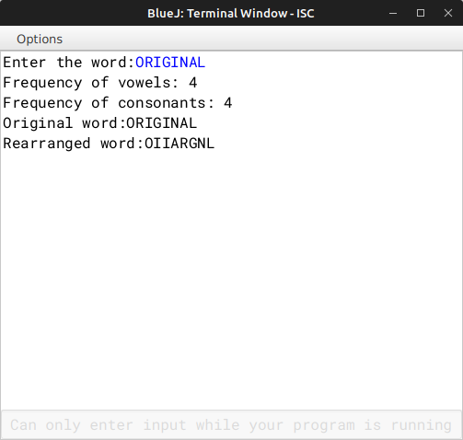

|  |  |  |  |  |
| --- | --- | --- | --- | --- |
| VD TABLE |  | | | |
|  | Sr. No. | Variable | Data Type | Description |
|  | 1 | wrd | String | Store the input word |
|  | 2 | newwrd | String | Store the rearranged word |
|  | 3 | v | int | Stores no. of vowels |
|  | 4 | c | int | Stores no. of consonants |
|  | 5 | v | String | Stores all the vowels of the word |
|  | 6 | c | String | Stores all the consonants of the word |
|  | 7 | i | int | Looping variable in freq_vow_con() & arrange() |

# Program 20

Design a class Perfect to check if a given number is a perfect number or not.

[A number is said to be perfect if sum of the factors of the number excluding itself is equal to the original number]

Example: 6 = 1 + 2 + 3 (where 1, 2 and 3 are factors of 6, excluding itself) Some of the members of the class are given below:

Class name: Perfect

Data members/instance variables:

num: to store the number

Methods/Member functions:

Perfect (int nn): parameterized constructor to initialize the data member num=nn

int sum_of_factors(int i): returns the sum of the factors of the number(num), excluding itself, using a recursive technique

void check(): checks whether the given number is perfect by invoking the function sum_of_factors() and displays the result with an appropriate message

Specify the class Perfect giving details of the constructor(), int sum_of_factors(int) and void check().

Define a main() function to create an object and call the functions accordingly to enable the task.

## 

## ALGORITHM

* Step-1 :- START
* Step-2 :- Create a class named as "Perfect".
* Srep-3 :- Create a parameterized constructor to initialize the instance variable int num and f with nn and 1 recpectively.
* Step-4 :- Create a int method "sum_of_factors(int i)" to sum up all the factors of a int i.
* Step-5 :- Create a void method "check()" to check the original no. is equal to the sum of factors of the no., and print the appropriate message.
* Step-6 :- Create the "main" to input the no. and pass it to the constructor and make a object and call the check() funtion.
* Step-7 :- END

|  |  |  |  |
| --- | --- | --- | --- |
| VD TABLE |  | | |
| Sr. No. | Variable | Data Type | Description |
| 1 | num | int | Store the input no. |
| 2 | f | int | Increment variable for the |

no., to find all its factors

3 n int Stores the user input no. int the main methods

## OUTPUT

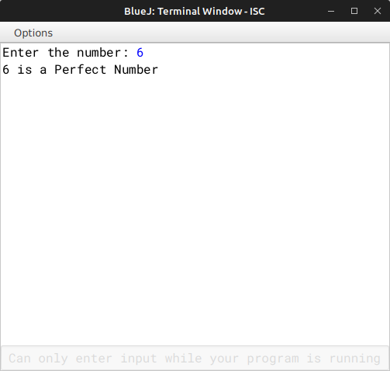

# Program 21

Two matrices are said to be equal if they have the same dimension and their corresponding elements are equal.

For example, the two matrices A and B is given below are equal:

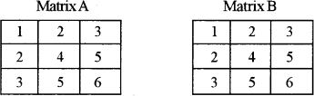

Design a class EqMat to check if two matrices are equal or not. Assume that the two matrices have the same dimension.

Some of the members of the class are given below:

Class name: EqMat

Data members/instance variables:

a[][] : to store integer elements m: to store the number of rows

n: to store the number of columns

Member functions/methods:

EqMat(int mm, int nn): parameterized constructor to initialise the data members m = mm and n = nn

void readArray(): to enter elements in the array

int check(EqMat P, EqMat Q): checks if the parameterized objects P and Q are equal and returns 1 if true, otherwise returns 0

void print(): displays the array elements

Define the class EqMat giving details of the constructor EqMat(int mm, int nn), void readArray( ), int check(EqMat, EqMat) and void print( ). Define the main( ) function to create objects and call the functions accordingly to enable the task.

## 

## ALGORITHM

* Step-1 :- START
* Step-2 :- Create a class named as "EqMat".
* Srep-3 :- Create a parameterized constructor to initialize the instance variable int m, n and a[][] with mm, nn and a[][] with m and n.
* Step-4 :- Create a void method "readArray()" to input the elements of the arrays.
* Step-5 :- Create a boolean method "check(EqMat p, EqMat q)" to check if the elements of the array are equal or not.
* Step-6 :- Create a void method "print()" to print a matrix.
* Step-7 :- Create the "main" to user input the rows and columns for the matrixes and create two object for two matrixes and take input in those two matrix and print both matrixes and check if they are equal or not and print a appropriate message.
* Step-8 :- END

|  |  |  |  |
| --- | --- | --- | --- |
| VD TABLE |  | | |
| Sr. No. | Variable | Data Type | Description |
| 1 | m | int | Store the no. of rows |
| 2 | n | int | Store the no. of columns |
| 3 | mm | int | Constructor parameter for |
| 4 | nn | int | no. of rows  Constructor parameter for |
| 5 | a[][] | int | no. of columns  Array to store the matrix of |
| 6 | i | int | m rows and n columns  Looping variable in |
| 7 | j | int | readArray(), check(EqMat p, EqMat q), and print()  Looping variable in |
| 8 | rows | int | readArray(), check(EqMat p, EqMat q), and print()  Store the user input of rows |
| 9 | columns | int | Store the user input of |
|  |  |  | columns |

OUTPUT

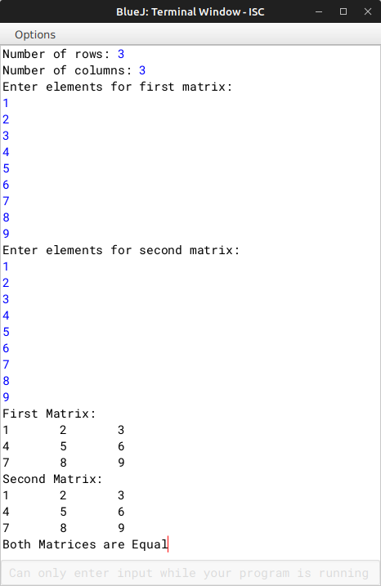

# Program 22

A class "Capital" has been defined to check whether a sentence has words beginning with a capital letter or not.

Some of the members of the class are given below:

Class name: Capital

Data member / instance variable:

sent: to store a sentence

freq: stores the frequency of words beginning with a capital letter

Member functions / methods:

Capital () : default constructor

void input (): to accept the sentence

boolean isCap(String w): checks and returns true if the word begins with a capital letter, otherwise returns false

void display(): displays the sentence along with the frequency of the words beginning with a capital letter

Specify the class Capital, giving the details of the constructor( ), void input( ), boolean isCap(String) and void display( ).

Define the main( ) function to create an object and call the functions accordingly to enable the task.

## 

## ALGORITHM

* Step-1 :- START
* Step-2 :- Create a class named as "Capital".
* Srep-3 :- Create a parameterized constructor to initialize the instance variable String sent with null,and int freq with 0.
* Step-4 :- Create a void method "input()" to input the sentence.
* Step-5 :- Create a boolean method "isCap(String w)" to check if the first letter of the sentence is capital or not.
* Step-6 :- Create a void method "display()" to count the no. of words and check if the words starts with a capital letter or not with the help of isCap(String w).
* Step-7 :- Create the "main" to create a object and call the "input()" & "output()" method.
* Step-8 :- END

|  |  |  |  |
| --- | --- | --- | --- |
| VD TABLE |  | | |
| Sr. No. | Variable | Data Type | Description |
| 1 | sent | String | Store the input string |
| 2 | freq | int | Store the no. of words in |
| 3 | ct | int | the String  Count the no. of words |
| 4 | w | String | Formal parameter for  isCap(String w) method |

5 i int Looping variable in display() for going through each word in the string and check them

OUTPUT

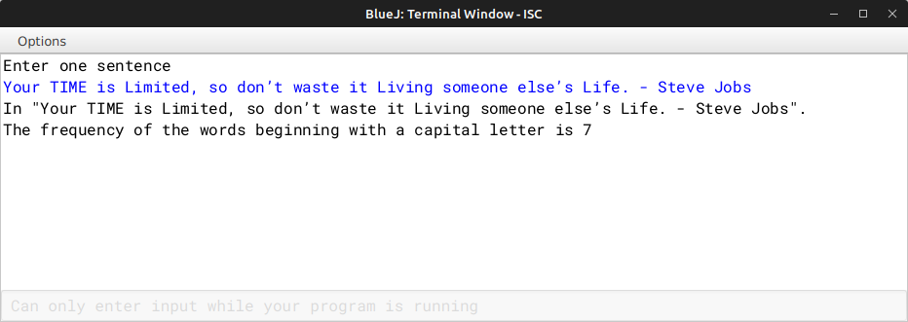

# Program 23

A Circular Prime is a prime number that remains prime under cyclic shifts of its digits. When the leftmost digit is removed and replaced at the end of the remaining string of digits, the generated number is still prime. The process is repeated until the original number is reached again.

A number is said to be prime if it has only two factors 1 and itself. Example:

131

311

113

Hence, 131 is a circular prime.

Accept a positive number N and check whether it is a circular prime or not. The new numbers formed after the shifting of the digits should also be displayed.

Test your program with the following data and some random data:

Example 1

INPUT:

N = 197

OUTPUT:

197

971

719

197 IS A CIRCULAR PRIME.

Example 2 INPUT:

N = 1193

OUTPUT:

1193

1931

9311

3119

1193 IS A CIRCULAR PRIME.

Example 3

INPUT:

N = 29

OUTPUT:

29

92

29 IS NOT A CIRCULAR PRIME.

## 

## ALGORITHM

* Step-1 :- START
* Step-2 :- Create a class named as circular_prime.
* Step-3 :- Create a method named as is_prime and pass a parameter num. In this function, check whether the number is prime or not.
* Step-4 :- Create a method named as getDigitCount and pass a parameter num. The function returns the number of digits in the number.
* Step-5 :- Create a method named as main. In this function, take a number as input from the user using Scanner Class. Now check for the invalid input. If the input is invalid, then print the message Invalid Input. Now check whether the number is prime or not. If the number is prime, then check whether the number is circular prime or not. If the number is circular prime, then print the number in the rotated forms. If the number is prime even after rotating, then print the message Circular Prime. If the number is not prime, then print the message Not a Prime Number.
* Step-6 :- END

|  |  |  |  |  |
| --- | --- | --- | --- | --- |
| VD TABLE |  | | | |
|  | Sr. No. | Variable | Data Type | Description |
|  | 1 | n | int | To store the number |
|  | 2 | num | int | To store the number |
|  | 3 | digitCount | int | To store the number of digits in the number |
|  | 4 | n2 | int | To store the copy of the original number |
|  | 5 | divisor | int | To store the remainder |
|  | 6 | isCircularPrime | boolean | To store the boolean value |
|  | 7 | t1 | int | Used as a temporary variable |
|  | 8 | t2 | int | Used as a temporary variable |
|  | 9 | i | int | Used as loop variable |
| OUTPUT |  |  |  |  |

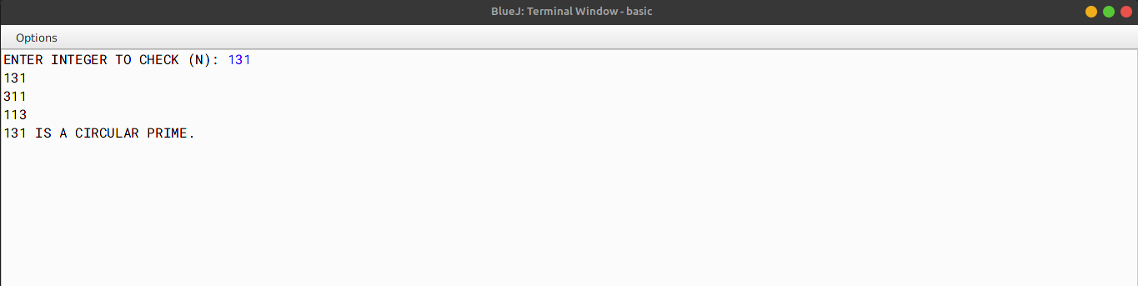

# Program 24

Write a program to declare a square matrix A[][] of order (M M) where 'M' must be greater than 3 and less than 10. Allow the user to input positive integers into this matrix. Perform the following tasks on the matrix:

Sort the non-boundary elements in ascending order using any standard sorting technique and rearrange them in the matrix.

Calculate the sum of both the diagonals.

Display the original matrix, rearranged matrix and only the diagonal elements of the rearranged matrix with their sum.

Test your program for the following data and some random data: Example 1

INPUT:

M = 4

|  |  |  |
| --- | --- | --- |
| 9 2 | 1 | 5 |
| 8 13 | 8 | 4 |
| 15 6 | 3 | 11 |
| 7 12 | 23 | 8 |

OUTPUT:

ORIGINAL MATRIX

|  |  |  |
| --- | --- | --- |
| 9 2 | 1 | 5 |
| 8 13 | 8 | 4 |
| 15 6 | 3 | 11 |
| 7 12 | 23 | 8 |

REARRANGED MATRIX

9 2 1 5

8 3 6 4

15 8 13 11

7 12 23 8

DIAGONAL ELEMENTS

9 5

3 6

8 13

7 8

SUM OF THE DIAGONAL ELEMENTS = 59

Example 2

INPUT:

M = 5

|  |  |  |  |
| --- | --- | --- | --- |
| 7 4 | 1 | 9 | 5 |
| 8 2 | 6 | 10 | 19 |
| 13 1 | 3 | 5 | 1 |
| 10 0 | 5 | 12 | 16 |
| 1 8 | 17 | 6 | 8 |

OUTPUT:

ORIGINAL MATRIX

|  |  |  |  |
| --- | --- | --- | --- |
| 7 4 | 1 | 9 | 5 |
| 8 2 | 6 | 10 | 19 |
| 13 1 | 3 | 5 | 1 |
| 10 0 | 5 | 12 | 16 |
| 1 8 | 17 | 6 | 8 |

REARRANGED MATRIX

|  |  |  |  |
| --- | --- | --- | --- |
| 7 4 | 1 | 9 | 5 |
| 8 0 | 1 | 2 | 19 |
| 13 3 | 5 | 5 | 1 |
| 10 6 | 10 | 12 | 16 |

1 8 17 6 8

DIAGONAL ELEMENTS

7 5

0 2

5

6 12

1 8

SUM OF THE DIAGONAL ELEMENTS = 46

Example 3 INPUT:

M = 3

OUTPUT:

THE MATRIX SIZE IS OUT OF RANGE.

## 

## ALGORITHM

* Step-1 :- START
* Step-2 :- Create a class named as rearrange.
* Step-3 :- Create a method named as sortNonBoundaryMatrix passing an array and an integer as parameters. In this function, sort the non-boundary elements of the matrix in ascending order by first converting the 2D array into 1D array and then sorting it and then again transferring in to 2D array.
* Step-4 :- Create a method named as computePrintDiagonalSum passing an array and an integer as parameters. In this function, compute the sum of the diagonal elements of the matrix and print the final sum.
* Step-5 :- Create a method named as printMatrix passing an array and an integer as parameters. In this function, print the matrix.
* Step-6 :- Create a method named as main. In this function, input the size of the matrix and the elements of the matrix from the user using the Scanner class. Then, call the sortNonBoundaryMatrix function and then the computePrintDiagonalSum function and finally call the printMatrix function.
* Step-7 :- END

OUTPUT

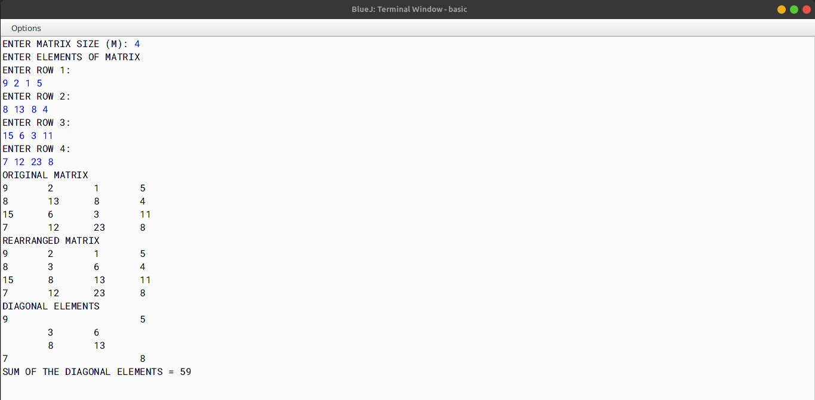

|  |  |  |  |
| --- | --- | --- | --- |
| VD TABLE |  | | |
| Sr. No. | Variable | Data Type | Description |
| 1 | m | int | To store the size of the |
| 2 | a | int[][] | matrix  Array to store the elements |
| 3 | i | int | of the matrix  Loop variable |
| 4 | j | int | Loop variable |
| 5 | t | int | Temporary variable to |
| 6 | sum | int | store the elements of the matrix  To store the sum of the |
| 7 | k | int | diagonal elements of the matrix  Temporary Variable |
| 8 | b | int[] | Array to store the elements |
|  |  |  | of the matrix (1D Format) |

# Program 25

Write a program to accept a sentence which may be terminated by either '.', '?' or '!' only. The words may be separated by more than one blank space and are in UPPER CASE.

Perform the following tasks:

Find the number of words beginning and ending with a vowel.

Place the words which begin and end with a vowel at the beginning, followed by the remaining words as they occur in the sentence.

Test your program with the sample data and some random data: Example 1

INPUT:

ANAMIKA AND SUSAN ARE NEVER GOING TO QUARREL ANYMORE.

OUTPUT:

NUMBER OF WORDS BEGINNING AND ENDING WITH A VOWEL = 3 ANAMIKA ARE ANYMORE AND SUSAN NEVER GOING TO QUARREL

Example 2 INPUT:

YOU MUST AIM TO BE A BETTER PERSON TOMORROW THAN YOU ARE TODAY.

OUTPUT:

NUMBER OF WORDS BEGINNING AND ENDING WITH A VOWEL = 2

A ARE YOU MUST AIM TO BE BETTER PERSON TOMORROW THAN YOU TODAY

Example 3 INPUT:

LOOK BEFORE YOU LEAP.

OUTPUT:

NUMBER OF WORDS BEGINNING AND ENDING WITH A VOWEL = 0 LOOK BEFORE YOU LEAP

Example 4

INPUT:

HOW ARE YOU@

OUTPUT:

INVALID INPUT

## 

## ALGORITHM

* Step-1 :- START
* Step-2 :- Create a class named as vowel.
* Step-3 :- Create a method named as isVowel and pass a character as a parameter. In this function, check if the character is a vowel or not.
* Step-4 :- Create a method named as main. In this function, input the sentence from the user using Scanner class. Now check whether the sentence is valid or not. Now place the words which begin and end with a vowel at the beginning, followed by the remaining words as they occur in the sentence. Print the sentence and number of words beginning and ending with a vowel.
* Step-5 :- END

VD TABLE

|  |  |  |  |  |
| --- | --- | --- | --- | --- |
|  | Sr. No. | Variable | Data Type | Description |
| 1 | ipStr | String | To store the sentence |
| 2 | word | String | To store the words |
| 3 | str | char | To store the trimed sentence |
| 4 | c | int | Used as counter variable |
| 5 | wordLen | int | To store the length of each word |
| 6 | newStr | String | To store the changed sentence |
| 7 | len | int | To store the length of the sentence |
| OUTPUT |  |  |  |  |

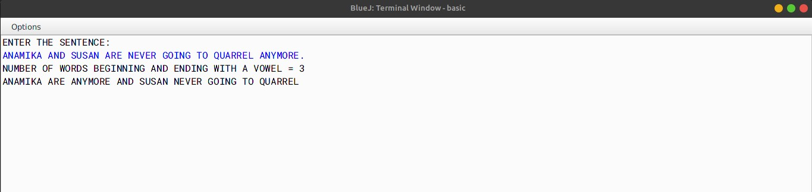

# Program 26

A class Adder has been defined to add any two accepted time.

Example: Time A 6 hours 35 minutes

Time B 7 hours 45 minutes

Their sum is 14 hours 20 minutes (where 60 minutes = 1 hour)

The details of the members of the class are given below:

Class name Adder

Data member/instance variable:

a[ ] integer array to hold two elements (hours and minutes)

Member functions/methods:

Adder( ) constructor to assign 0 to the array elements void readtime( ) to enter the elements of the array

void addtime( Adder X, Adder Y) adds the time of the two parameterized objects X and Y and stores the sum in the current calling object

void disptime( ) displays the array elements with an appropriate message (i.e. hours

= and minutes = )

Specify the class Adder giving details of the constructor( ), void readtime( ), void addtime(Adder, Adder) and void disptime( ). Define the main( ) function to create objects and call the functions accordingly to enable the task.

## 

## ALGORITHM

* Step-1 :- START
* Step-2 :- Create a class named as Adder.
* Step-3 :- Declare an array of type interger.
* Step-4 :- Create a constructor named as adder. In this constructor, initialize the array with size 2.
* Step-5 :- Create a method named as readtime. In this function, take the time input from the user using Scanner class.
* Step-6 :- Create a method named as add passing two parameterised objects X and Y. In this function, adds the time of the two parameterized objects X and Y and stores the sum in the current calling object.
* Step-7 :- Create a method named as display. In this function, display the time.
* Step-8 :- Create a method named as main. In this function, create two objects of the class Adder and call the methods.
* Step-9 :- END

## VD TABLE

Sr. No. Variable Data Type Description

|  |  |  |  |  |
| --- | --- | --- | --- | --- |
|  | 1 | a | int[] | To store the time |
| 2 | a | int | To store the hour |
| 3 | b | int | To store the minute |
| 4 | c | int | To store the addition of time of the two objects |
| OUTPUT |  |  |  |  |

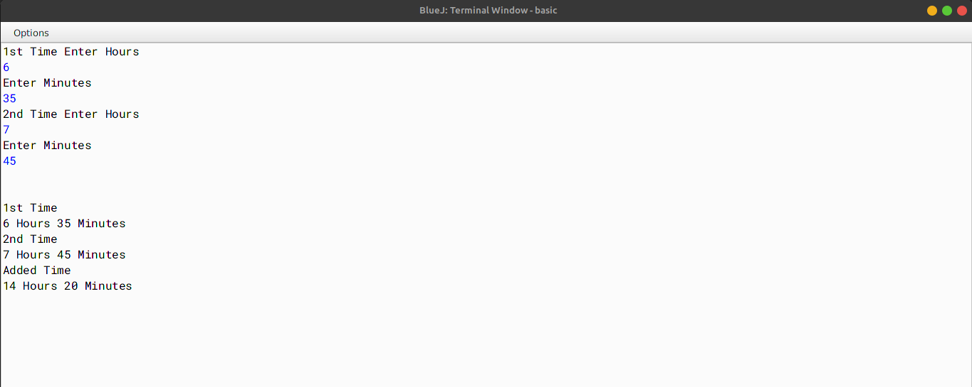

# Program 27

A class SwapSort has been defined to perform string related operations on a word input. Some of the members of the class are as follows:

Class name: SwapSort

Data members/instance variables:

wrd; to store a word

len: integer to store length of the word swapwrd: to store the swapped word sortwrd: to store the sorted word

Member functions/methods:

SwapSort(): default constructor to initialize data members with legal initial values void readword(): to accept a word in UPPER CASE

void swapchar(): to interchange/swap the first and last characters of the word in wrd and

stores the new word in swapwrd

void sortword(): sorts the characters of the original word in alphabetical order and stores it

in sortwrd

void display(): displays the original word, swapped word and the sorted word

Specify the class SwapSort, giving the details of the constructor(), void readword( ), void swapchar( ), void sortword( ) and void display( ). Define the main( ) function to create an object and call the functions accordingly to enable the task.

## 

## ALGORITHM

* Step-1 :- START
* Step-2 :- Create a class named as SwapSort.
* Step-3 :- Declare wrd to store a word, len integer to store length of the word, swapwrd to store the swapped word,

sortwrd to store the sorted word.

* Step-4 :- Create a contrustor named as SwapSort to initialize data members with legal initial values.
* Step-5 :- Create a method named as readword to accept a word in UPPER CASE.
* Step-6 :- Create a method named as swapchar to interchange/swap the first and last characters of the word in

wrd and stores the new word in swapwrd.

* Step-7 :- Create a method named as sortchar to sort the characters of the word in swapwrd and stores the new word in sortwrd.
* Step-8 :- Create a method named as main to create an object and call the functions accordingly to enable the task.
* Step-9 :- END

VD TABLE

|  |  |  |  |  |
| --- | --- | --- | --- | --- |
|  | Sr. No. | Variable | Data Type | Description |
| 1 | wrd | String | To store a word |
| 2 | len | int | To store length of the word |
| 3 | swapwrd | String | To store the swapped word |
| 4 | sortwrd | String | To store the sorted word |
| 5 | i | int | To store the index of the word |
| 6 | j | int | To store the index of the word |
| 7 | c | char | To store the temporary character |
| OUTPUT |  |  |  |  |

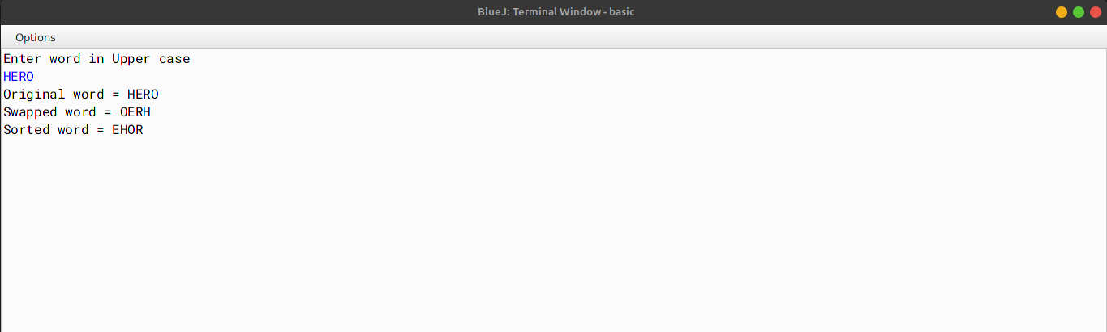

# Program 28

A disarium number is a number in which the sum of the digits to the power of their respective position is equal to the number itself.

Example: 135 = 11 + 32 + 53 Hence, 135 is a disarium number.

Design a class Disarium to check if a given number is a disarium number or not. Some of the members of the class are given below:

Class name: Disarium

Data members/instance variables:

int num: stores the number

int size: stores the size of the number Methods/Member functions:

Disarium(int nn) : parameterized constructor to initialize the data members n = nn

and size = 0

void countDigit() : counts the total number of digits and assigns it to size

int sumofDigits(int n, int p) : returns the sum of the digits of the number(n)

void check( ) : checks whether the number is a disarium number and displays the

result with an appropriate message

Specify the class Disarium giving the details of the constructor( ),

void countDigit(), int sumofDigits(int, int) and void check( ). Define the main( ) function to create an object and call the functions accordingly to enable the task.

## 

## ALGORITHM

* Step-1 :- START
* Step-2 :- Create a class named as Disarium.
* Step-3 :- Declare variables - num to store the number and size to store the size of the number.
* Step-4 :- Create a constructor named as Disarium to initialize the variables to initial values.
* Step-5 :- Create a method named as countDigits to count the number of digits in the number.
* Step-6 :- Create a method named as sumofDigits with two interger type parameters to return the sum of the digits of the number.
* Step-7 :- Create a method named as check to check whether the number is a disarium number and display the result with an appropriate message.
* Step-8 :- Create a method named as main to to create an object and call the functions accordingly to enable the task.
* Step-9 :- END

## VD TABLE

Sr. No. Variable Data Type Description

|  |  |  |  |  |
| --- | --- | --- | --- | --- |
|  | 1 | num | int | To store the number |
| 2 | size | int | To store the size of the number |
| 3 | m | int | To store the input number by the user |
| 4 | a | int | Temporary variable |
| OUTPUT |  |  |  |  |

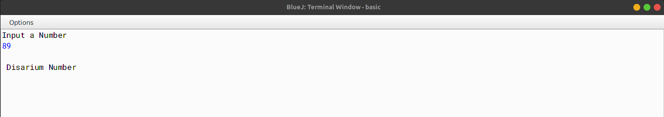

# Program 29

A class Shift contains a two-dimensional integer array of order (m n) where the maximum values of both m and n is 5. Design the class Shift to shuffle the matrix (i.e. the first row becomes the last, the second row becomes the first and so on). The details of the members of the class are given below:

Class name: Shift

Data member/instance variable:

mat[ ][ ] : stores the array element

m : integer to store the number of rows

n : integer to store the number of

columns

Member functions/methods:

Shift(int mm, int nn ) : parameterized constructor to initialize the data

members m = mm and n = nn

void input( ) : enters the elements of the array

void cyclic(Shift P) : enables the matrix of the object(P) to shift each row upwards in a

cyclic manner and store the resultant matrix in the current object

void display( ) : displays the matrix elements

Specify the class Shift giving details of the constructor( ), void input( ),

void cyclic(Shift) and void display( ). Define the main( ) function to create an object and call the methods accordingly to enable the task of shifting the array elements.

## 

## ALGORITHM

* Step-1 :- START
* Step-2 :- Create a class named as Shift.
* Step-3 :- Declare variables - mat[ ][ ] to stores the array elements, m to store the number of rows and n to store the number of columns.
* Step-4 :- Create a constructor named as Shift with two integer type integers, to initialize the variables to

initialize the data.

* Step-5 :- Create a method named as input to input the elements of the array.
* Step-6 :- Create a method named as cyclic to enable the matrix of the object(P) to shift each row upwards in a cyclic manner and store the resultant matrix in the current object.
* Step-7 :- Create a method named as display to display the elements of the array.
* Step-8 :- Create a method named as main to create an object of the class Shift and call the methods.
* Step-9 :- END

|  |  |  |  |
| --- | --- | --- | --- |
| VD TABLE |  | | |
| Sr. No. | Variable | Data Type | Description |
| 1 | mat[ ][ ] | int | To store the array elements |
| 2 | m | int | To store the number of |
|  |  |  | rows |
| 3 | n | int | To store the number of |
| 4 | i | int | columns  To store the row number |
| 5 | j | int | To store the column |

number

6 mm int To store the number of rows inside the constructor

- Shift

7 nn int To store the number of columns inside the constructor - Shift

OUTPUT

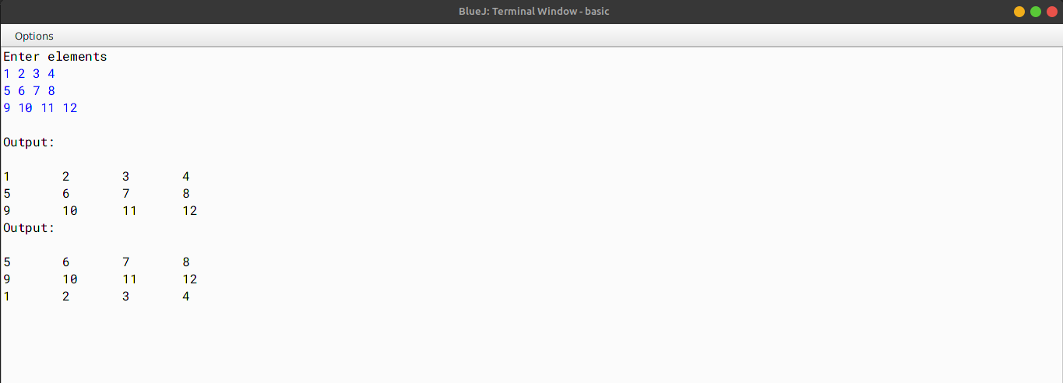

# Program 30

A class ConsChange has been defined with the following details:

Class name : ConsChange

Data members/instance variables:

word : stores the word

len : stores the length of the word

Member functions/methods:

ConsChange( ) : default constructor

void readword( ) : accepts the word in lowercase

void shiftcons( ) : shifts all the consonants of the word at the beginning followed

by the vowels (e.g. spoon becomes spnoo)

void changeword( ) : changes the case of all occurring consonants of the shifted

word to uppercase, for e.g. (spnoo becomes SPNoo)

void show( ) : displays the original word, shifted word and the changed word

Specify the class ConsChange giving the details of the constructor( ),

void readword( ), void shiftcons( ), void changeword( ) and void show( ). Define the main( ) function to create an object and call the functions accordingly to enable the task.

## 

## ALGORITHM

* Step-1: - START
* Step-2: - Create a class named as ConsCharge.
* Step-3: - Declare variables - word to store the word and len to store the length of the word.
* Step-4: - Create a constructor named as ConsCharge to initialize the variables to default values.
* Step-5: - Create a method named as readword to accept the word in lowercase.
* Step-6: - Create a method named as shiftcons to shift all the consonants of the word at the beginning

followed by the vowels.

* Step-7: - Create a method named as changeword to change the case of all occurring consonants of the

shifted word to uppercase.

* Step-8: - Create a method named as show to display the original word, shifted word and the changed word.

|  |  |  |  |
| --- | --- | --- | --- |
| VD TABLE |  | | |
| Sr. No. | Variable | Data Type | Description |
| 1 | word | String | To store the word |
| 2 | len | int | To store the length of the |

word

3 i int To store the index of the word

4 c char To store the character of the word

5 s String To store the shifted word (in shiftcons() function)

6 s String To store the shifted word (in changeword() function)

OUTPUT

